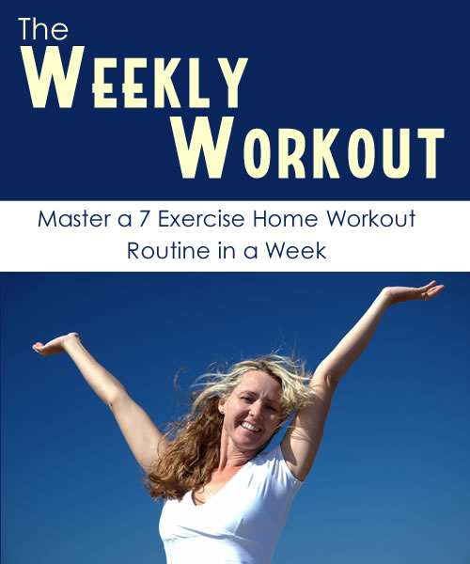

Table Of Contents

Intro 2

Monday - Power Walk 2

Tuesday - Triangle Push Up 2

Wednesday - Body Weight Squat 2

Thursday - The Curl-Up 2

Friday - Shadow Boxing 2

Saturday - Dips 2

Sunday - Power Jumps 2

Conclusion 2

Intro

This guide is designed to show you one new calorie burning exercise per day. We have broken the guide down like that for ease of training. The exercises are probably familiar to you but the classic exercises are just that for a reason - they work and they are easy.

Each day we introduce a new exercise. Once introduced you should use it the following days as well. Eventually at the end of the week you will be doing each exercise everyday.

It will be your daily 7 Exercise routine.

This workout is low impact enough that you can do it everyday, but that is up to you. The more you do it the better the results.

If you want to make any of these exercises more challenging, simply raise the reps or sets. A rep is doing the exercise once, while a set is a number of those reps. You can also add weights to make some of the exercises tougher.

Please consult your doctor before you take on any new training regimen.

Calories burned are approximated and can swing wildly depending on things like current weight and other circumstances.
Monday - Power Walk

This is one of the easiest activities to add to your daily routine.

Barring a disability, most of us walk everyday. We have grown up walking, jogging and running. Most times people start exercising by walking and or running. That is often the only exercise people do.

This is because it is easy and effective.

You can do this inside on a treadmill, but I suggest outside. The varied terrain and wind resistance will make for a better exercise. It is also mentally soothing to go for a walk outside.

This is not a casual stroll though, you will want to keep your pace up on this walk. If power walk is too tame for you, you can also jog or run.

How To’s & Tips

- In power walking posture counts. Stand up straight as possible. This will allow all your muscles through the core to work together and it will help you walk faster.
- Look ahead not down.
- Relax Shoulders
- Walk with your arms close to body and a 90 degree angle at the elbow.
- Stride forward at a brisk pace you can handle, your heel should be striking the ground first.
- Wear firm soled comfortable shoes. Power walking shoes are preferred.

Duration: 20 Minutes
Calories Burned: ~300

Tuesday - Triangle Push Up

The triangle push up is a variation of the push up most of us are familiar with. This simple variation will work more muscles in your upper body.

I would do this exercise after the power walk personally. The power walk will have your blood flowing and make you more receptive to this muscle building exercise.

This push up is just like the normal push up except that you bring your hands in so your thumbs and pointer fingers are forming a triangle.

How To’s & Tips

- Kneel face down.
- Place your hands on the floor and position them below your chest with your thumbs and pointer fingers close enough to form a triangle.
- Stretch out into normal push up position, parallel to the ground.
- Lower your self down near ground level and then push yourself up again to complete one push up.
- If you can not complete this motion, then you can keep your knees on the ground until you have built up enough arm strength to do the full version.
- To complete a full set do 10 pushups with no break in between.
- Do three of these sets.

Duration: 3 Sets of 10
Calories Burned: ~75
Wednesday - Body Weight Squat

This is one of the most popular exercises for serious weight trainers. While they do theirs with huge weights on their back, this body weight only version is still effective.

A squat works primarily your legs, but the amazing thing is it also works man other muscles in your body. Weight trainers refer to this exercise as a true full body workout.

Learning the body weight squat is usually suggested before you move onto weighted squats.

The squat is basically done from the standing position, and you squat down towards the ground, in a sitting motion. Then you finish the squat by standing back up straight.

If you don’t find the body weight squats challenging enough, then add dumbbells in each of your hands. Make sure to have the same weight on each side.

How To’s & Tips

- Stand up with your feet a little more than shoulder width apart, toes pointed 30 degrees out.
- Squat down into a sitting like position.
- Squat as far as you are comfortable with.
- Some people squat until their thighs are parallel with ground, others like the slightly break that plane.
- Don’t risk your form for speed. Keeping the proper form is more important than finishing quickly.
- Squatting down and then back up is a rep.
- A set is 10 reps.

Duration: 3 Sets of 10
Calories Burned: ~105
Thursday - The Curl-Up

Another variation on a classic exercise. This exercise is based on the sit-up which is one of the first exercises you will learn along with running and pushups. This exercise burns calories, while working the abdominal and other core muscles.

This exercise is slightly different than a sit-up or crunch. Some studies have shown it causes less impact on the lower back. The exercise is essentially a crunch, but the arms stay at the side of the body. This is to protect the neck and back muscles.

One rep is a curl up and then back down onto the mat.

How To’s & Tips

- Lie down on your back, if you have an exercise or yoga mat, use that.
- Place your hands at your sides, arms straight forward and on the mat or ground.
- Contract your abs, curl up as if you were doing a crunch moving your hands along the ground towards your heels. Keep your head up.
- Return to the starting point and that is one rep.

Duration: 3 Sets of 10
Calories Burned: ~75
Friday - Shadow Boxing

It is estimated that people are 38% more likely to stick with a new exercise if they find it fun or enjoyable. It makes sense that you would find it easier to do a task that you actually find fun This is why shadow boxing is a great exercise.

It is not just for combat sports enthusiasts either. Shadow boxing is a good aerobic workout, easy to do and somewhat therapeutic. This exercise not only works your body, it can help soothe your mind.
It provides a great outlet for your day’s frustrations.

If you want to up the resistance in the exercise and make it more challenging you can add weights to your hands, or use a heavy bag with boxing gloves.

How To’s & Tips

- Great thing about shadow boxing is it isn’t as form dependent as other exercises.
- Stand comfortably. Hold your hands up, making a tight fist with your thumb tight against the outside of your fingers.
- Do not tuck your thumb inside fingers, if you accidentally hit something your thumb could be injured.
- Keep your elbows close to your body and your chin tucked down
- Throw some punches as if you were boxing.
- Start throwing a couple jabs and then work up in speed as the exercise progresses.
- While punching you should be moving around, keep on the balls of your feet.
- Remember to use head movement and lean back and forth as if you were avoiding punches from an opponent.
- Have fun!

Duration: 15 Minutes (one minute break 2x in there)
Calories Burned: ~105
Saturday - Dips

This exercise burns calories as well as builds muscle. This is one of the best body weight work outs for your arms. This is an exercise you will probably feel in your arms a day (or more likely 2) after you have done it.

This exercise can be done a couple different ways, but in general using two a dining room chair is perfect. Like most exercises in this book, this exercise is so convenient you could do it in a hotel room on a business trip. It just takes your own body weight and a chair.

The general idea is that you raise your own body weight with just your arms.

How To’s & Tips

- Stand in front of a chair, facing away from it.
- Sit down on the very edge of the chair.
- Place your hands so they are on the edge of the chair about shoulder width apart.
- Make sure your hands are secured and slide your butt of the edge of the chair, walking out with your feet. Keep your chest and head up.
- Slowly lower your body downward. Don’t bend your elbows past 90 degrees.
- Now push your body back up by extending your arms.
- Lowering down and then raising up constitutes one rep.
- If 3 sets of 8 reps is too much start out with one set and work your way up.
- If you find this exercise too easy, an advanced dip can be performed by resting your feet on edge of another chair.

Duration: 3 Sets of 8
Calories Burned: ~75
Sunday - Power Jumps

We saved this exercise for the last day because it is a great way to wind down your days activities. It is one last explosive body weight exercise to finish your routine out.

You will want to make sure you have room to do this exercise, and are on a firm floor. You probably don’t want to jump around anything fragile or that could fall off a shelf. The key to this exercise is using your core muscles to explode, you don’t want to hold back on the jumps because you are scared of knocking something over. If it is a nice day this is a great exercise to get out into the yard and do.

It is pretty easy to do, since most of us have been jumping since were kids. If you want to add difficulty the exercise, hold some light dumbbells in each hand (same weight).

How To’s & Tips

- Find somewhere you are comfortable jumping as high as possible.
- Stand up with your knees slightly bent and your feet close together.
- Bend down then jump straight up as high as you can.
- Land with your knees loose to absorb impact.
- As you land go into a squat position and then explode into your next jump as you rise up.
- One jump is one rep.
- Read the squat lesson from Wednesday to figure out what a squat position is

Duration: 3 Sets of 10
Calories Burned: ~125

Conclusion

You now have a 7 exercise routine that you can use at any times. If you feel like the workout is too strenuous break it up so you do 3 one day and 4 the next. Ideally though you would like to perform all 7 activities per day.

You can also break up the activities throughout the day. YOu could take your power walk first thing each morning, and then do a couple of the other exercises each time you take a break. These are the perfect exercises for people who stay or work from home as well.

A very rough approximation is that going through all of these exercises will burn 900 calories. This number can vary wildly based on gender, and body weight and level of exertion.

If you need further instruction on these exercises, look them up on Google and YouTube there are both pictures and videos of the above exercises available online.

